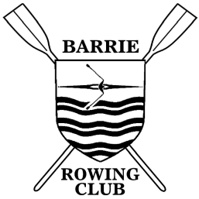
Support Fee Refund Request Form
Please print and submit to the club manager.

Membership Year: April 1, 20 to March 31, .

By way of this application, I (print name clearly) am making a request to the Barrie Rowing Club Board of Directors for the return of my support fee of submitted with my membership fees. (Annual memberships: minimum of 24 hours to be completed by returning adult members and 12 hours by new/student members. Summer specials: minimum of 6 or 10 hours).

PLEASE NOTE: Activities must be approved by a Club Official before consideration for refund.

Below is a detailed account of the project(s) and/or volunteer time completed and the dates:

Date of Activity | Details of Work Completed Including Name of Organizer | # of hours

Signed By: ________________________________ Date: ________________________
(Member Applying)

Approved By: ______________________________ Date: ________________________
(Designated Club Representative)

